***A PROJECT ON***

# “IMAGE CLASSIFICATION USING CNN”

SUBMITTED IN

PARTIAL FULFILLMENT OF THE REQUIREMENT FOR THE COURSE OF

DIPLOMA IN BIG DATA ANALYSIS



**SUNBEAM INSTITUTE OF INFORMATION TECHNOLOGY, PUNE**

Submitted By:

Aryan Kushwaha (86789)

Hrushabh Patil (87172)

**Mr.Nitin Kudale Mrs.Manisha Hingne** Centre Coordinator Course Coordinator



**CERTIFICATE**

This is to certify that the project work under the title ‘Image Classificatio using CNN’ is done by Aryan Kushwaha & Hrushabh Patil in partial fulfillment of the requirement for award of Diploma in Big Data Analysis Course.

Mr. Aniket P Mrs. Manisha Hingne

**Project Guide** **Course Coordinator**

Date:

# ACKNOWLEDGEMENT

A project usually falls short of its expectation unless aided and guided by the right persons at the right time. We avail this opportunity to express our deep sense of gratitude towards Mr. Nitin Kudale (Center Coordinator, SIIT, Pune) and Mrs. Manisha Hingne (Course Coordinator, SIIT ,Pune) and Project Guide Mr. Aniket P.

We are deeply indebted and grateful to them for their guidance, encouragement and deep concern for our project. Without their critical evaluation and suggestions at every stage of the project, this project could never have reached its present form.

Last but not the least we thank the entire faculty and the staff members of Sunbeam Institute of Information Technology, Pune for their support.

Aryan Kushwaha

DBDA Aug 2024 Batch, SIIT Pune

Hrushabh Patil

DBDA Aug 2024 Batch, SIIT Pune

.

**TABLE OF CONTENTS**

1. **Introduction**
   1. Introduction And Objectives
   2. Why this problem needs To be Solved?
   3. Dataset Information

## Problem Definition and Algorithm

* 1. Problem Definition
  2. Algorithm Definition

## Experimental Evaluation

* 1. Methodology/Model
  2. Exploratory Data Analysis

## Results And Discussion

1. **GUI**
2. **GitHub link**

## 7.Future Work And Conclusion

* 1. Future Work
  2. Conclusion
     1. **Introduction**
        1. **Introduction And Objectives:**

Image classification is a type of supervised learning issue where a collection of target classes (things to identify in photographs) is defined. Based on the tagged sample photos,a model is trained to recognize the target classes. The development of the Convolutional Neural Network (CNN),which can extract higher-level representations of the visual material, was a significant advancement in the process of creating models for image classification. A CNN essentially learns how to extract these options and determine what item they contain by using the image's raw component data as input rather than preprocessing the data to produce options like textures and forms.

Machines are trained using training data that has been labelled accurately, and then they anticipate the outcome using supervised learning, a form of machine learning concept. The labelled data refers to some input data for which the suitable output label has been applied. The supervisor instructs the computers to accurately forecast the

outcome using the data (training data) that is supplied to them. It makes use of a similar idea to how a pupil learns while being supervised by a teacher. Supervised learning is a method of providing the machine learning model with the appropriate input data, input knowledge, and output data. The aim of supervised learning is to find a mapping function to connect the input variable (x) with the output variable (y). In the actual world, supervised learning is widely used for tasks like risk assessment and image categorization, spam filtering, fraud detection, etc. In supervised learning, the models are trained using labelled datasets so that they may learn about various types of data. After the training phase is finished, the model is evaluated using test data, which is a subset of the training set, and makes a prediction of the outcome.

## Literature Review

Object identification and image analysis both heavily rely on picture classification. There have been many different image classification methods put forth so far. In an effort to determine the optimum image categorization method, numerous studies have been undertaken. Over the past few decades, conventional methods have been regularly altered to produce the most accurate results possible, and new picture categorization techniques have also been created.

The current focus of this project is combining the desired aspects of various strategies to boost a typical dataset's efficiency. Abhinav N Patil [1] from Vishwakarma University, India, performed research on classification of “imagery data using custom neural network with the architecture of Convolution Neural Networks and Keras API. His aim was to classify the images based on the built model (using Convolutional Neural Network Algorithm) with higher accuracy. Results were fluctuated a bit but according to the average, the accuracy was well around 90-95% percent with a layer filter of 256. More powerful hardware could have achieved even higher results and with much extended dataset for more categories than just two for training.”

Leslie D [4], from The Alan Turing Institute, conducted experimental research on “Understanding bias in facial recognition technologies” that stated, “CNNs break down a digital image’s two-dimensional array of pixel values into smaller parts, but instead of sliding rectangular shapes across the image looking for matches, they zoom in on particular patches of the image using smaller grids of pixels values called kernels.”

**2. Methodology:**

The primary goal of this study is to develop a more accurate picture categorization model utilizing convolutional neural networks (CNN). In this research, input will be an image provided by the user/ customer. The user/ customer will upload the image and has to click on submit button to classify that image. The image uploaded will be undergone through various pre-processing techniques like padding, fitting, etc. Based on the trained model, the pixel data and RGB data will be authorized, and the image will be classified among the categories. If the user does not provide any image and clicks on submit button, then an error pop-up message will be initiated. All the processing will be done using the trained model which is stored over the cloud. Different outputs will be generated depending on what module the users take or what input they will give. Based on the type of image provided, the model will categorize it. For example, Bedroom, Bathroom, Gym, Swimming Pool, etc. The entire process involved is represented in the form of a control flow diagram in the below fig-1.

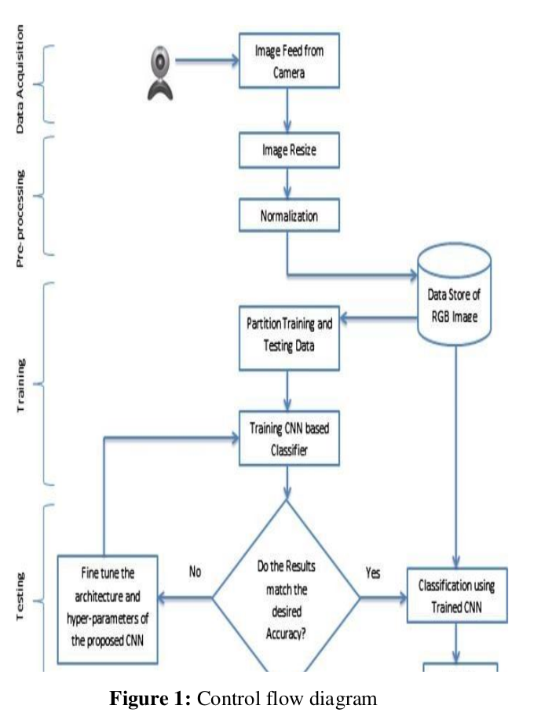

**2.1 Image Processing**

Image processing entails digitizing an image and applying various techniques to it in order to extract some useful information. When implementing a set of prescribed signal processing processes, the image processing system normally interprets all images as 2D signals. The steps performed in this research are illustrated in the below fig-2

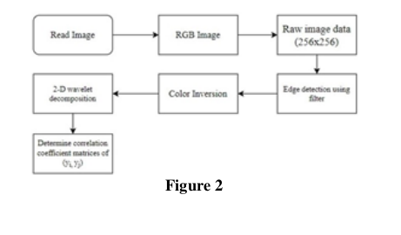

## 2.2 Image Feature Extraction

## Computer vision and image processing both use the concept of feature extraction. It describes the procedure of gathering image data with the aid of a computer and determining if the points on a specific image are included in image feature extraction. The division of the image's points into several subsets is the aim of feature extraction. Frequently, these subsets consist of an area, a continuous curve, or single points.

## “The time-frequency composite weighting algorithm for multi-frame blurred images is a frequency-domain and time-

## domain weighting simultaneous processing algorithm based on blurred image data. Based on the weighted characteristic

## of the algorithm and the feature extraction of the target image in the time domain and frequency domain, the depth

## extraction technique is based on the time-frequency composite weighting of the night image to extract the target

## information from the depth image” [5].

## The time-frequency weighted feature extraction approach involves the following primary steps:

## Step 1: Create a time-frequency weighted signal model for a number of blurry photos.

## Step 2: After translating the one-dimensional function of the time scale and the time shift to the two-dimensional function of the time scale and the time shift, transform the continuous nighttime image of the image using a time-frequency composite weighted with a square-integrable function.

## Step 3: Create a time-frequency composite weighted signal form

## Step 4: The multi-thread fuzzy image's time-frequency weighted signal's frequency modulation law is a hyperbolic function.

## Step 5: Apply the time-frequency weighting to the image using the multi-detector fuzzy image weighted signal image transformation formula (the definition of the image transformation is similar to the formula).

## An image time-frequency weighted image signal will be the output in the end. Therefore, the time-frequency composite

## weighting algorithm can better realise this image feature extraction technique than the conventional time-domain.

## **2.3 Classifier**

## A classifier is then required to categorize the feature vectors once the feature vectors have been extracted using the image and the image has been characterized as a vector of static length. A input layer, activation layer, convolution layer, complete connection layer, pool layer and final output layer are the layers that make up a standard convolution neural network from input to output. Layer by layer, input data is transferred from the convolutional layer, which establishes the connections among various computational neural nodes, while the continuous convolution-pool structure decodes, infers, transfers the original data's feature signals to the feature space of the hidden layer. The following entire connection layer identifies and produces using the features that were extracted. Steps involved in the process of classification of raw data is illustrated in fig-3.

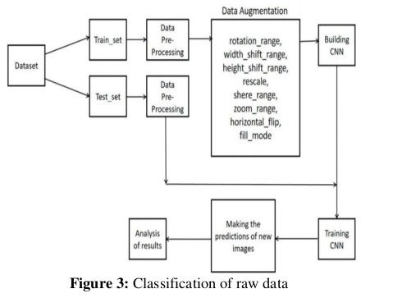

**3. Experimental Setup**

The images of any type of hotel room can be trained on this network. However, the machine must meet certain hardware

and software requirements.

H/W Requirements (Application Specific Hardware):

* Installed libraries – PIL, NumPy, pandas, keras, Matplotlib, TensorFlow, h5py
* Processor i3
* UNIX based OS
* 8Gb RAM
* Required environments: Ipython, python 23.10
* 2Gb graphic card

S/W Requirements (Application Specific Software): Python-compatible environment (python3+) for training the convolution network. K-20 GPU enabled EC2

**4. Convolutional Neural Network**

A deep learning approach used for object recognition is a convolutional neural network. The idea behind CNN is to teach the network how people learn new things. A massive dataset is used to train a CNN. A unique method is used by each layer of the CNN to extract features from the image. Since all the layers are interconnected, all the extracted

features can be integrated at the end. To distinguish between human and non-human faces, CNN will also undergo training using non-human faces. To calculate the characteristics, CNN uses iterative calculations.

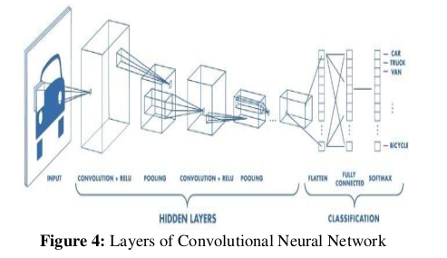

**5. Testing**

Based on the dataset, the model is evaluated using model.compile() and model.fit_generator() function, and fig-7 shows the accuracy of the model on test data and the accuracy of the model on training data.

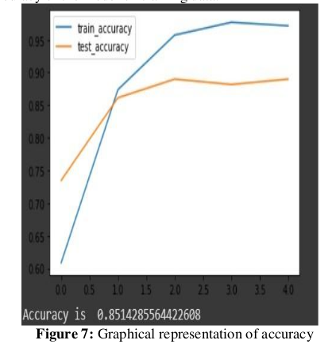

The model is trained with required epochs and in the picture, we can see the loss and validation loss pair and the accuracy of training data and validation data accuracy. Below fig-8 shows the detailed information on training which involves the total number of epochs, loss, train_accuracy, and val_accuracy.

**6. Conclusion**

In this project, we used Convolutional Neural Networks (CNN) for image classification using images from hotel room data sets. Using CNN, this set of data was used for both training and testing. It provides an accuracy rate of 98% for the training dataset and 85% for the test dataset using the Vgg16 model. Images used for the training purpose are small and RGB images. The processing of these photographs takes a significantly long amount of time computationally when compared to typical JPEG images. Results for image classification will be more accurate if the model is built with more layers and trained on more picture data using GPU clusters.

The future enhancement of classifying images of large sizes is very useful for the image segmentation process. The main aim of this project is that whenever a user uploads an image to give a review to the hotel, then one person should sit at the back to arrange these images into their corresponding folders. So, this is a hectic work for the person. Our project focuses to make this automation. So, when the user uploads an image on the website then the VGG16 model which is attached at the backend will detect the image and redirects the image to its corresponding folder. And this Flask server is running on an AWS EC2 machine, user can access this website from anywhere in the world by using either the IP address of the machine or by using the DNS name assigned to that corresponding IP address.

**7. References**

[1] Patil, Abhinav, Image Recognition using Machine

Learning (February 1, 2021). Available at SSRN:

https://ssrn.com/abstract=3835625

or

http://dx.doi.org/10.2139/ssrn.3835625.

[2] Yechuri Sandeep,” Deep Convolutional Neural

Networks (CNN) to learn features of images and

Backpropagation (BP) Neural Networks and SVMs

for classification.,” Satyabhama Institute of Science

and Technology, India, 2014.

[3] Shanya Sanjay Verma, Dr. Sureshkumar N, "Image

Processing

for

Crop

Yield

Classification",

International Journal of Science and Research (IJSR),

Volume 8 Issue 12, December 2019, pp. 1768-1771,

https://www.ijsr.net/get_abstract.php?paper_id=ART2

0203802

[4] Leslie, David, Understanding Bias in Facial

Recognition Technologies (September 26, 2020).

Leslie, D. (2020). Understanding bias in facial

recognition technologies: an explainer. The Alan

Turing

Institute.

https://doi.org/10.5281/zenodo.4050457, Available at

SSRN:

https://ssrn.com/abstract=3705658

or

http://dx.doi.org/10.2139/ssrn.3705658

[5] Xin, M., Wang, Y. Research on image classification

model based on deep convolution neural network. J

Image

Video

Proc.

2019,

40

(2019).

https://doi.org/10.1186/s13640-019-0417-8

